Question 1 Calc Free (11 marks)

The water tank near the house on a farm has a capacity of 4000 litres and needs to be filled regularly. There is a gauge on the side to show the volume of water in the tank.

On Tuesday at 5:00am, Alice turned on the pump used to transfer water into the tank. The pump delivers water at the rate of 200 litres per hour.

(a) Complete the table below. (3 marks)

Number of hours pump was working | 1 | 2 | 3 | 5
Volume of water in the tank (in litres) |  | 560 |  |  | 1360

(b) What was the volume of water in the tank at 8:00am? (1 mark)

(c) If $T_{2}$ represents the volume of water in the tank after the pump has been working for
2 hours and $T_{2}$ = 560 , write a recursive formula to determine the volume. (2 marks)

(d) Clearly, a relationship exists between the ”Number of hours the pump was working ” and the “Volume of water in the tank”. Is the relationship linear or exponential? Explain your choice. (2 marks)

(e) How much water was in the tank at 2:00pm? (2 marks)

(f) How long was the pump working last Tuesday for the volume of water in the tank to reach 3760 litres? (1 mark)

Question 1 (a)
Solution
Number of hours pump was working | 1 | 2 | 3 | 5 | 6
Volume of water in the tank (in litres) | 360 | 560 | 760 | 1160 | 1360

Marking key/mathematical behaviours | Marks
- determines starting value and third term  - determines 5th term  - identifies term number | 1  1  1

Question 1 (b)
Solution

760 litres
Marking key/mathematical behaviours | Marks
- relates sequence to context of problem | 1

Question1 (c)
Solution
$T_{n+1 = }T_{n + }$200 $T_{1}$= 360
Marking key/mathematical behaviours | Marks
- describes recursive relation  - identifies starting term (or any particular term) | 1  1

Question 1 (d)
Solution

Linear. The increase is a constant number
Marking key/mathematical behaviours | Marks
- identifies correct relationship  - justifies choice of type | 1  1

Question 1 (e)
Solution

1960
Marking key/mathematical behaviours | Marks
- identifies correct term (n = 9)  - determines correct value | 1  1

Question 1 (f)
Solution

18 hours
Marking key/mathematical behaviours | Marks
- identifies correct term | 1

Question 2 Calc Allowed (16 marks)

Tigers are one the world’s most endangered species. In an effort to protect the few thousand tigers remaining, reserves have been established in South Asia and the population of tigers has been increasing on these reserves.

On one reserve, the annual growth of the tiger population from 2012 to 2015 can be expressed by the recursive formula

$P_{n+1}=1.07P_{n}$ where $P_{1}$ = 427

- What has been the annual rate of increase in the tiger population on this reserve since 2012?
(1 mark)

Assume that the population of tigers on the reserve will continue to increase at the same rate.

- Use the formula given above to complete this table, rounding to the nearest whole number.
(3 marks)

Year | 2012 | 2013 | 2014 | 2015 | 2017
Number of tigers at the end of the year | 427 |  |  |  |  | 641

(c) (i) Deduce the non-recursive rule for the n^{th} term of the population of tigers on this reserve.
(2 marks)

(ii) Use this rule to calculate the tiger population on the reserve in 2020.
(2 marks)

(d) If the data in the table were presented on a graph, would you expect the points to be in a line? Justify your decision. (2 marks)

(e) The year 2022 is the next “Year of the Tiger” on the Chinese calendar.
What is the predicted population of tigers on the reserve for 2022? (2 marks)

(f) During which year is the population of tigers expected to be greater than 1000 for the first time?
(2 marks)

(g) Describe how the prediction in part (f) will be affected if the calculation for the population changes to $P_{n+1}=1.08P_{n}$. Explain your decision. (2 marks)

Question 2 (a)
7%
Marking key/mathematical behaviours | Marks
- states the correct percentage | 1
Question 2 (b)
Year | 2012 | 2013 | 2014 | 2015 | 2017 | 2018
Number of tigers | 427 | 457 | 489 | 523 | 599 | 641

Marking key/mathematical behaviours | Marks
- determines correct year for population of 641  - determines another two entries  - determines another two entries | 1  1  1
Question 2 (c) (i)
$$P=427×{1.07}^{(n-1)}$$
Marking key/mathematical behaviours | Marks
- expresses rule in correct format with correct starting term  - uses correct factor of ${1.07}^{(n-1)}$ in rule | 1  1
Question 2 (c) (ii)
$P=427×{(1.07)}^{8}$
=686
Marking key/mathematical behaviours | Marks
- identifies correct term  - determines correct population | 1  1
Question 2 (d)
No because the difference between the annual populations is not constant
Marking key/mathematical behaviours | Marks
- concludes correctly  - justifies conclusion | 1  1
Question 2 (e)
For 2022, n =11
$P_{11}=427×{(1.07)}^{10}$= 839
Marking key/mathematical behaviours | Marks
- identifies correct term n = 11  - determines population | 1  1

Question 2 (f)
$$P_{? }>=1000$$
? = 14
2025
Marking key/mathematical behaviours | Marks
- identifies procedure to solve problem  - determines correct year | 1  1
Question2 (g)
The population will reach the target before 2025 (earlier)
There is an increase in the rate of growth
Marking key/mathematical behaviours | Marks
- identifies earlier time  - describes faster growth | 1  1

Question 3 Calc Allowed (11 marks)
Data from the Australian Bureau of Statistics showed that the population of pigs in Australia fell by the same rate in each of the 2013-2014 and 2014-2015 financial years. Assuming the population continues to fall at the same rate each year and the population at the end of June 2015 is approximately 242 thousand, the n^{th} term of the sequence,
P = 242 (0.985) ^{n-1}

gives the expected population of pigs (in thousands), n years after 30 June, 2015.
The graph shows the expected change in population over time (years).
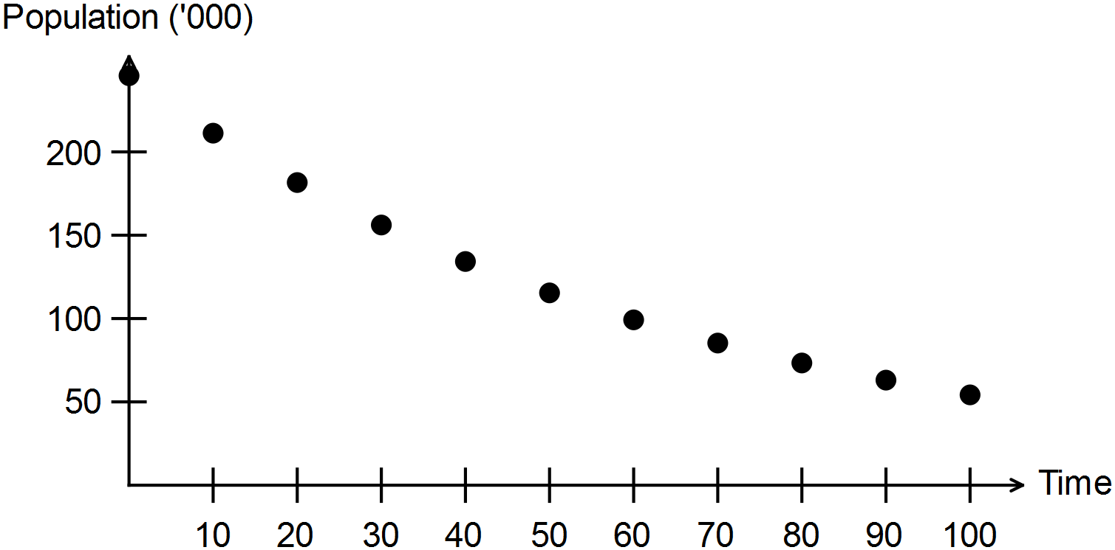

(a) Determine the rate at which the population is falling each year. (1 mark)

(b) Describe the type and nature of the change in the predicted population. (2 marks)

(c) State the value of the first term of the sequence. (1 mark)

(d) Determine the expected size of the pig population in Australia at the end of June 2021.
(1 mark)

(e) If populations are recorded every 12 months, when will the population of pigs first be recorded as below 200 000? (2 marks)

(f) To halt the decline in the pig population, it has been suggested that 5000 pigs could be imported each year. Complete the table provided to show the pig populations with and without this option and complete the rules to determine the recurrence relation for each option.
(4 marks)

Date | No pigs imported | 5000 pigs imported each year after 2015
30 Jun 2015 | 242 000 | 242 000
30 Jun 2016
30 Jun 2017
Linear recurrence relation | P₀ = 242 000  ............................................. | P₀ = 242 000  ....................................................

Question 3 (a)
Falling at 1.5% per year
Marking key/mathematical behaviours | Marks
- identifies rate of decline | 1

Question 3 (b)
The population change is classified as exponential decay.
Marking key/mathematical behaviours | Marks
- identifies decay or negative change  - identifies the change is exponential | 1  1

Question 3 (c)
242 000
Marking key/mathematical behaviours | Marks
- identifies first term | 1

Question 3 (d)
The 7th term is 242 x 0.985 ⁶ = 221 020
Marking key/mathematical behaviours | Marks
- determines 7th term | 1

Question 3 (e)
June 30, 2028
Marking key/mathematical behaviours | Marks
- identifies recording at the end of June  - determines correct year | 1  1

Question 3 (f)
Date | No pigs imported | 5000 pigs imported each year after 2015
30 Jun 2015 | 242 000 | 242 000
30 Jun 2016 | 238 370 | 243 370
30 Jun 2017 | 234 794 | 244 719
Linear recurrence relation | P₀ = 242 000  P_{n+1} = 0.985 P_{n} | P₀ = 242 000  P_{n+1} = 0.985 P_{n} + 5

Marking key/mathematical behaviours | Marks
- enters number of pigs for first option  - enters number of pigs for second option  - identifies linear recurrence relation for first option  - identifies linear recurrence relation for second option | 1  1  1  1

Question 4 Calc Allowed (6 marks)

For each of the sequences given below, describe the pattern by selecting the appropriate description in each column and writing the description in the table provided.

Sequence | Arithmetic or geometric | Exponential or linear | Growth or decay
A
B
C
D
E
F

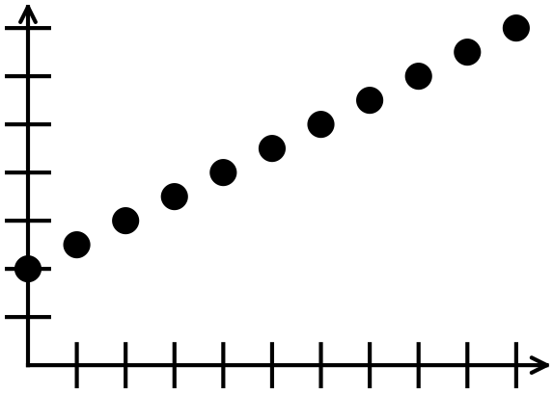  A | B  Each year the number of cards that Kay sends to her friends is 0.9 times the number she sent the previous year. Consider the sequence formed by listing the number of cards that Kay sends each year.
C  n 1 2 3 4 5  T_{n} 128 96 72 54 40.5 | D  n 1 2 3 4 5  T_{n} -100 -90 -80 -70 -60
E  For the first five weeks of his new job, Joel works an extra 2.5 hours each week. Consider the sequence formed by listing the number of hours that Joel works each week. | F  The number of library books needing to be replaced each year is deemed to be declining at a rate of 10%. Consider the sequence formed by listing the number of books needing to be replaced each year.

Question 4
Solution

Sequence | Arithmetic or geometric | Exponential or linear | Growth or decay
A | arithmetic | linear | growth
B | geometric | exponential | decay
C | geometric | exponential | decay
D | arithmetic | linear | growth
E | arithmetic | linear | growth
F | geometric | exponential | decay

Marking key/mathematical behaviours | Marks
- Identifies of given sequence | 6

Question 5 Calc Free (8 marks)

(a) A number sequence is described using the recursive equation:

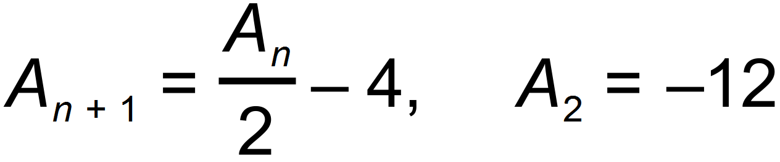

(i) Determine 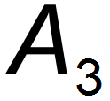 (1 mark)

(ii) Determine 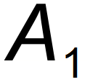 (2 marks)

(b) For the sequence 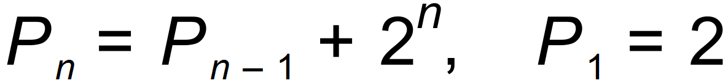

(i) Determine the next three terms. (3 marks)

(ii) Based on the results in (bi) the equation 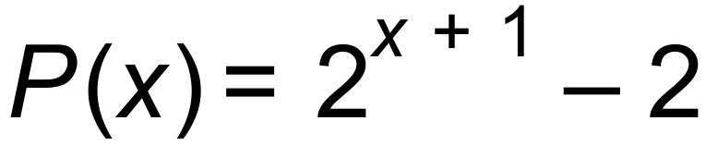 can be formed.
Show, using both methods, that when x = 5, 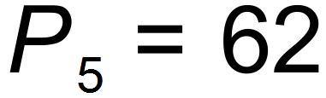. (2 marks)

5. (a) (i) 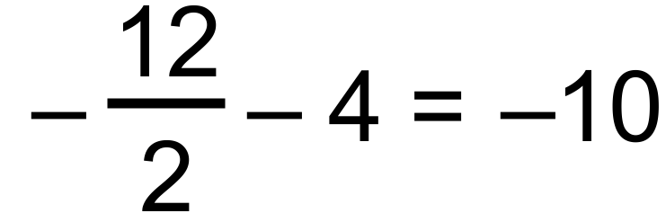
(ii) 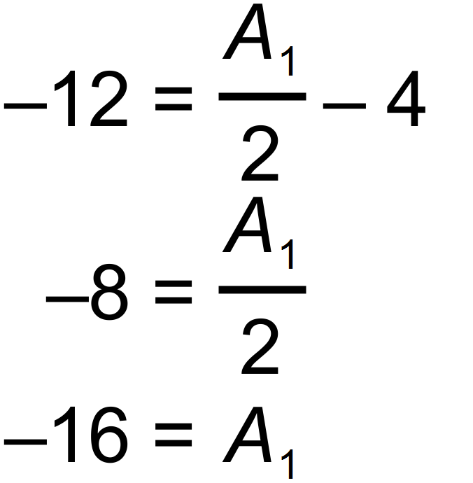

(b) (i) 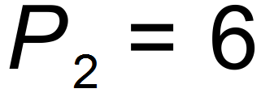
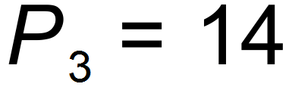
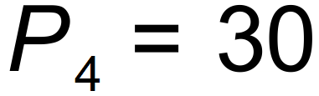

(ii) 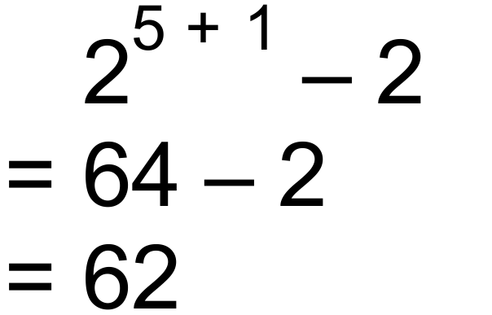 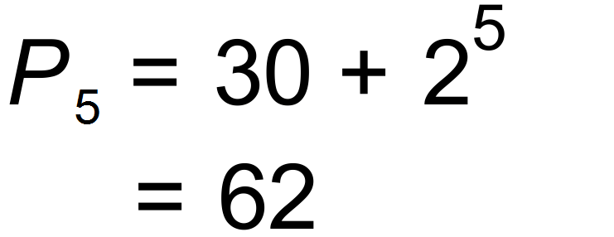 [8]

Question 6 Calc Free (4 marks)

Use the table below to match each recursive equation with the statement.

Use the letter of each recursive equation (A, B, C, D) and the letter of the statement (a, b, c, d).

A: 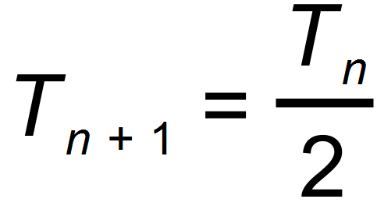 B: 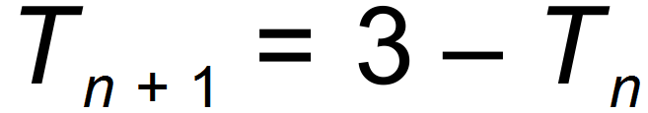 C: 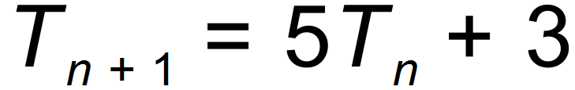 D: 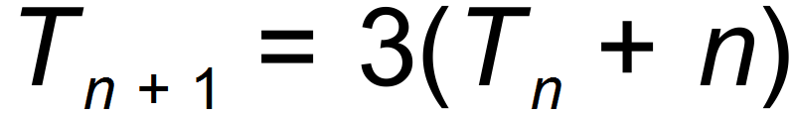

a: Each term is obtained by subtracting the previous term from 3.

b: Each term is obtained by adding the term number of the previous term to the previous term and
multiplying by 3.

c: Each term is obtained by multiplying the previous term by 5 and adding 3.

d: Each term is obtained by multiplying the previous term by 0.5.

Recursive  Equation | A | B | C | D
Statement

Question 6

Recursive  Equation | A | B | C | D
Statement | d | a | c | b
[4]

Question 7 Calc Assumed (7 marks)

The introduction of a new pesticide has affected the population of a species of grasshopper.
Scientists believe that the breeding cycle per month of the grasshopper is now based on the
given recursive equation.

(a) What was the population when the scientists developed this equation? (1 mark)

(b) Is the population increasing/decreasing? (1 mark)

(c) Determine the percentage change in the population. (1 mark)

(d) What will the population be in 5 months? (1 mark)

(e) What will the population be in 3 years? (1 mark)

(f) When is the population 20% of its initial population? (1 mark)

(g) Without rounding, does the population reach exactly zero? (1 mark)

Question 7 Calc Assumed (7 marks)

(a) 2500
(b) Decreasing
(c) 17% per month
(d) 984.76 accept 984 or 985
(e) 3.05 accept 3
(f) During the 9th month
(g) No [7]

Question 8 Calc Assumed (11 marks)

Planes take off on a runway made of concrete and from a particular numbered sign post. At one airport the concrete runway and vegetation at either end measures five kilometres in length. The runway has a number of sign posts, an exact distance from each other, along the length of the concrete. As a plane leaves the terminal, the first sign post the captain of the plane sees is numbered 3035, the second is numbered 3275, followed by 3515, etc.

(a) Determine the distance between each sign post. (1 mark)

(b) Show why the number on the first sign post is 155. (2 marks)

(c) Write a recursive definition for the sequence of sign post numbers. (2 marks)

(d) Determine the number on the last sign post. (2 marks)

(e) What percentage of the length of the runway is vegetated? (1 mark)

(f) If a plane has to have at least 4100 metres to commence its take - off, what
sign post does it have to start from? (2 marks)

(g) A plane starts at the 8th sign. Determine the maximum distance it has for
take – off. (1 mark)

Question 8 Calc Assumed (11 marks)

(a) 240 metres

(b) 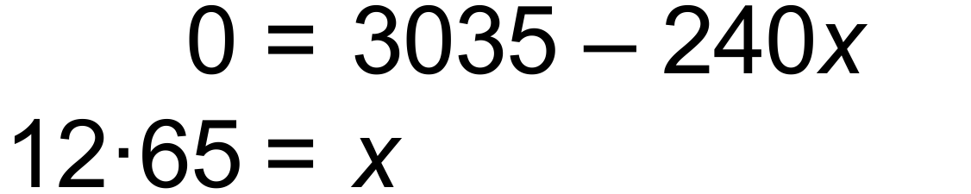

metres

(c)

(d) 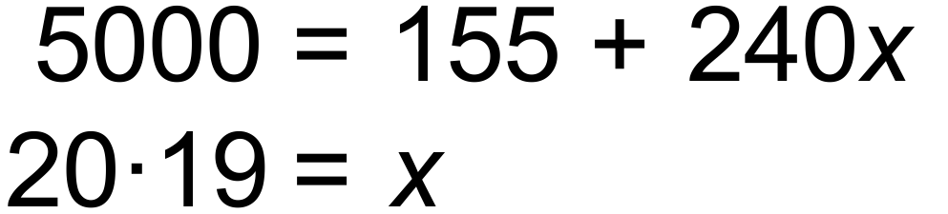

metres

(e) 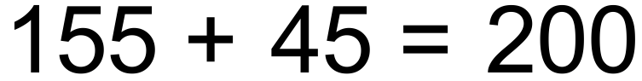  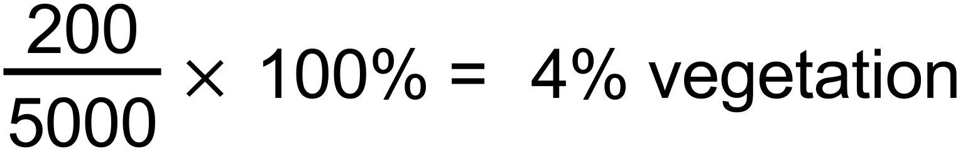

(f) 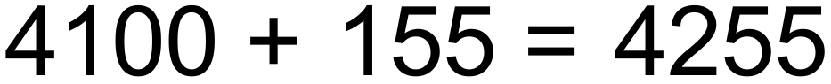

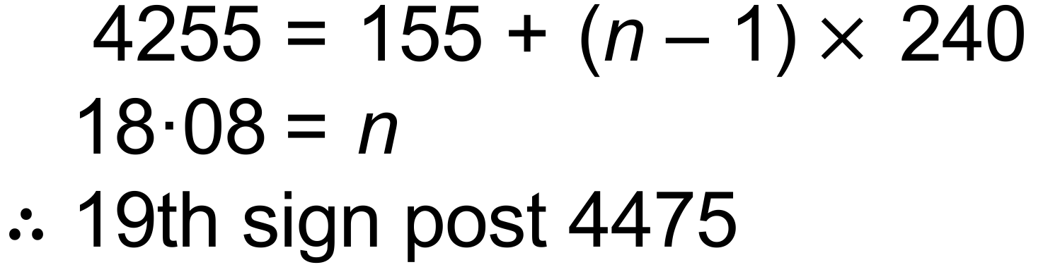

(g) [11]

Question 9 Calc Assumed (7 marks)

(a) Determine the exact value of T₇ for the following two sequences, one of which is arithmetic and the other is geometric.
(i) 14, 17, 20, 23, 26, ...
(1 mark)

(ii) 500, 400, 320, 256, 204.8, ...

(1 mark)
(b) A sequence is given by $T_{n+1}=5-2T_{n} T_{1}=3$

- Calculate $T_{2}$.
(1 mark)

- What is the smallest value of n for which $T_{n}≥300$.
(1 mark)

- After clean-up operations began on a small oil slick, it was observed that the area of the slick decreased by 8% every hour. The initial area of the oil slick was 550m².

- What was the area of the slick 1 hour after clean-up began?
(1 mark)

- Write a rule A_{n} to determine , the area of the slick n hours after clean-up operations began.
(2 marks)

Question 9 Calc Assumed (7 marks)

Question 10 Calc Assumed (7 marks)

- The size of a population of feral cats can be represented by the recurrence relation
$P_{n+1}=0.8P_{n}+50, P_{0}=76,$ where $P_{n}$ is the size of the population after $n$ months.

- Determine the size of the population after 1 month.
(1 mark)

- Determine the size of the population after 12 month.
(1 mark)

- Comment on the size of the cat population in the long term.
(2 marks)

- Another population of 24 feral cats was observed to grow to 44 after one year and increase to 74 after two years. The size of this population can be represented by $P_{n+1}=r×P_{n}+k, P_{0}=a$ where $P_{n}$ is the size of the population after $n$ years.

Determine the values of$r$, $k$ and $a$.

Question 10 Calc Assumed (7 marks)

Question 11 Calc Assumed (7 marks)

Austin believes that student marks improve exponentially with each practice paper they complete after sitting their mock exam.
He states his belief in the following way. M_{n+1} = 1.04M_{n}, M₀ = E , where E is the mock exam score out of 100 marks.

(a) State the fixed percentage increase. (1 mark)

Daphne scores 60 marks in her mock exam.

(b) What is Daphne’s predicted mark, correct to 1 decimal place, if she completes :

(i) 1 practice paper? (2 marks)

(ii) 4 practice papers? (2 marks)

Austin refines his formula for Daphne. He adds the statement that n < 14.

(c) Why did he do this? (2 marks)

Question 11 Calc Assumed (7 marks)

8. (a) 4%
(b) (i) 1.04(60) = 62.4
(ii) 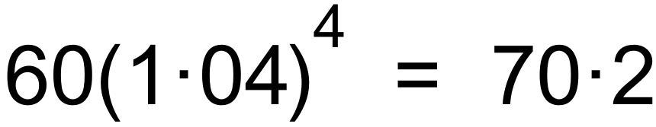
(c) Because if n = 14, 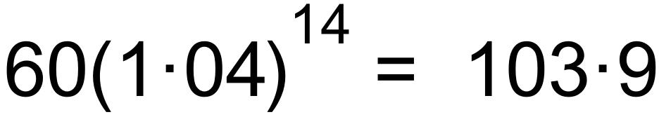 which is more than
the maximum of 100 marks. [7]

Question 12 Calc Assumed (3 marks)

Consider the first order recurrence relation given by:

4A _{n+1} = 3A _{n}, A₁ = 5

(a) State the values of term 2 and term 3. (2 marks)

The sequence has a steady state solution.

(b) What is the value of that solution? (1 mark)

Solutions Question 12 Calc Assumed (3 marks)

(a) A₂ = 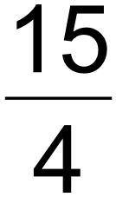 = 3.75, A₃ = 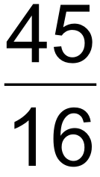 = 2.8125

(b) By solving 4A_{n} = 3A_{n} or by interrogating a table,
steady state solution is A_{n} = 0 [3]

Solutions Question 13 Calc Free (9 marks)

(a) Consider this recursive rule:

T_{n+1} = T_{n} – 5 T₂ = 100

(i) Determine T₃ (1 mark)

(ii) Determine T₁ (1 mark)

(iii) Determine T₁₁ (1 mark)

(b) A sequence is such that T₁ = 15, T₄ = 30, T₅ = 35 and T₆ = 40

(i) State a recursive rule for the sequence. (2 marks)

The points ( n, T_{n} ) are graphed.

(ii) State the shape of the graph. (1 mark)

(iii) State the gradient of the graph. (1 mark)

(iv) State the T_{n} intercept of the graph. (1 mark)

(v) State the equation of the graph. (1 mark)

Solutions Question 13 Calc Free (9 marks)

(a) (i) T₃ = T₂ – 5 = 95

(ii) T₁ = 105

(iii) T₁₁ = 105 + 10 ( - 5) = 55

(b) (i) T_{n+1} = T_{n} + 5, T₁ = 15
(ii) Linear
(iii) 5
(iv) 10
(v) T_{n} = 10 + 5n [9]

